

Synopsis Report

for

Admission Portal

Submitted By: -

MembersUniversity Roll NO.

|  |  |
| --- | --- |
| 1. RAVI SHANKAR PANDEY | 2100100100128 |
| 2. NEEL KAMAL | 2100100100101 |
| 3. RAJU KUSHWAHA | 2100100310027 |

Submitted To: -

MR.GAURAV NARAIN SINGH

(Assistant Professor)

UNITED COLLEGE OF ENGINEERING AND RESEARCH, PRAYAGRAJ

Dr. A.P.J. Abdul Kalam Technical University



A-31, UPSIDC, Industrial Area, Naini Prayagraj

Website: [www.united.ac.in](http://www.united.ac.in/).

**Table of Contents**

|  |  |  |
| --- | --- | --- |
| SR NO. | Topic | Page No. |
| 1. | Introduction | 3 |
| 2. | Aim and Objective | 4 |
| 3. | Hardware and software requirement | 6 |
| 4. | Reference | 7 |
| 5. | Conclusion | 8 |

# Introduction

It is type Admission Portal which deals with all kind of student details like student id, permanent address, date of birth and many more. This provide the facility of giving relief from obstacle in storing the data when the network connection is interrupted or lost. With the help of this admission portal any authenticated user can store the data of student at any time without internet connection.

AIM OF ADMISSION PORTAL

The Aim of this project is to create a Admission Portal which will be helpful to teachers, students and college to store the full information about the student. This Admission Portal will provide the facility of storing the information related data into the database using the admission portal. This provide the facility of giving relief from obstacle in storing the data when the network connection is interrupted or lost. With the help of this admission portal any authenticated user can store the data of student at any time without internet connection.

OBJECTIVE

* To be familiar with Database Connectivity.
* To learn more about storing structure of database.
* To learn purpose of project development.
* To get easily everything about study.
* To learn more about Java

SNAPSHOT OF PROJECT

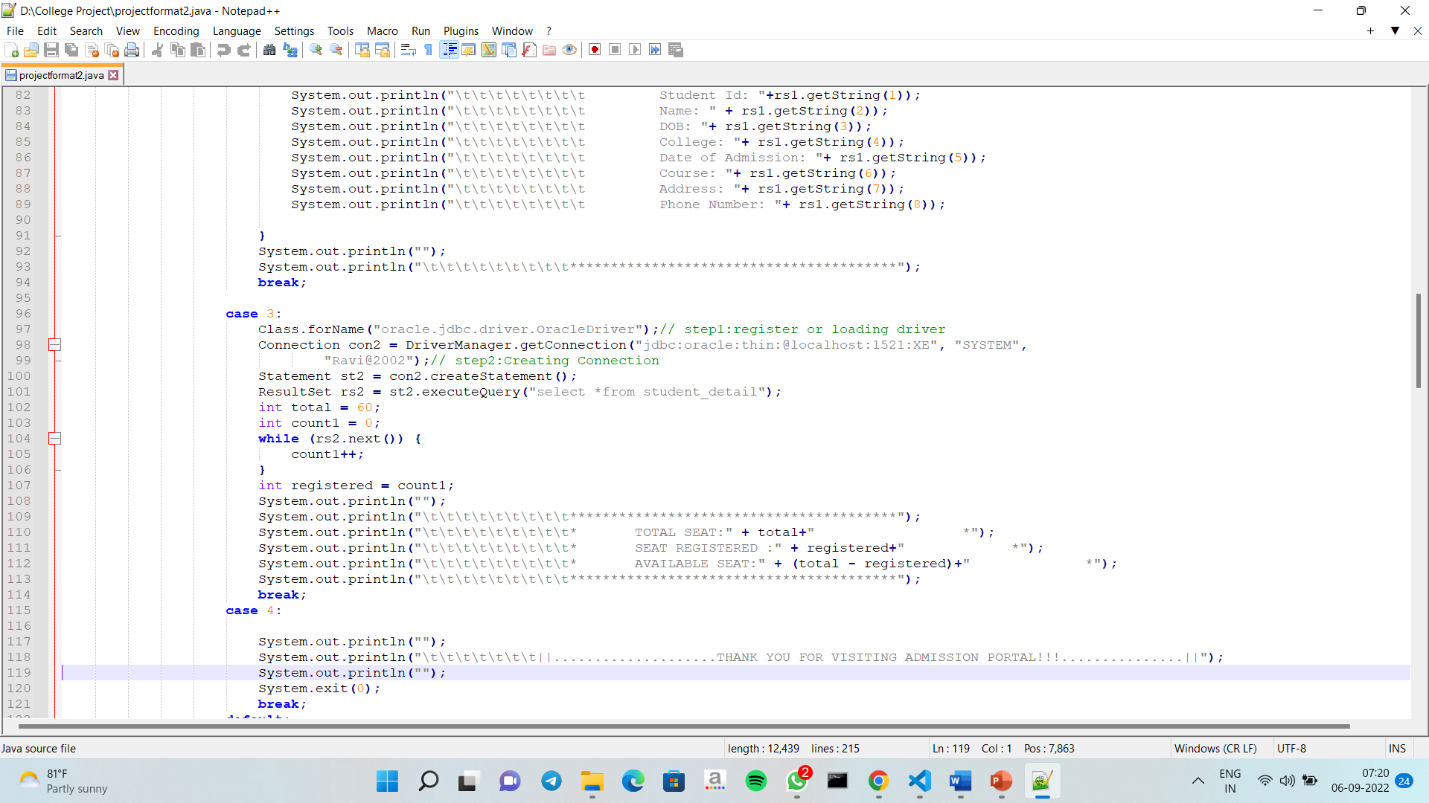

# HARDWARE AND SOFTWARE REQUIREMENTS: -

* 1. Operating system: windows 7/8/10/11. etc.
  2. Processor: 1.2 GHz.
  3. Memory required: 512 MB.
  4. Storage required: 10 MB.
  5. Browser: Microsoft edge/chrome etc.
  6. Application: Notepad/ Vs code /Oracle Database etc.
  7. Oracle Database

# REFERENCE: -

## TEXT-

* CORE JAVA summer training by Gaurav Singh Sir and under the guidance of faculty of CSE department.

## WEB SOURCE-

* <https://www.geeksforgeeks.org/java/?ref=>
* <https://stackoverflow.co/teams/>
* <https://www.oracle.com/in/database/technologies/>

CONCLUSION

This project concludes that with the help of java language we can create the

connectivity with the database, we can manage the record and data stored in

the database, we can insert delete and fetch the data with Java language. This

project uses the multiple feature of Java language.